**PRACTICAL NO: 8**

**AIM:** Create wireless network in OMNET++.

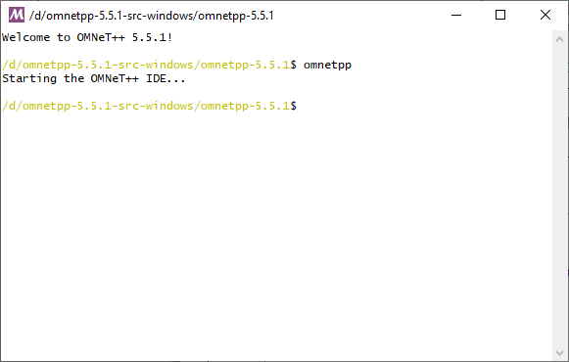**Step 1:** Go to omnetpp-5.5.1 folder in which open “mingwenv.cmd” file, we get following window. Type “omnetpp” command to open omnet++ IDE.

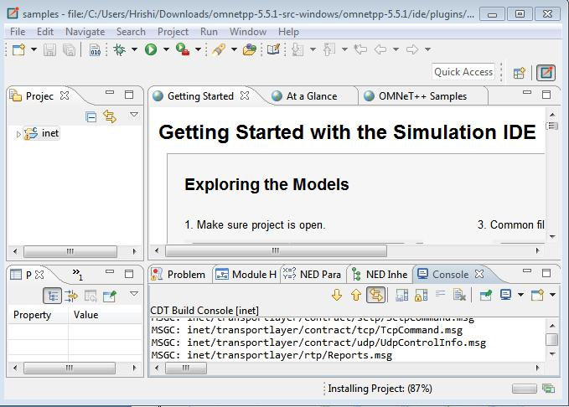**Step 2:** after that command, following window will open.

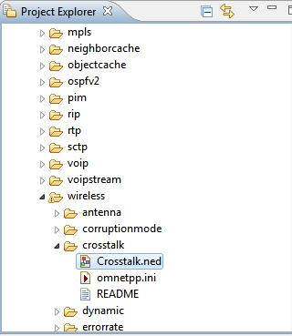**Step 3:** Go to project Explorer > inet > examples > wireless > crosswalk and open Crosstalk.nedfile.

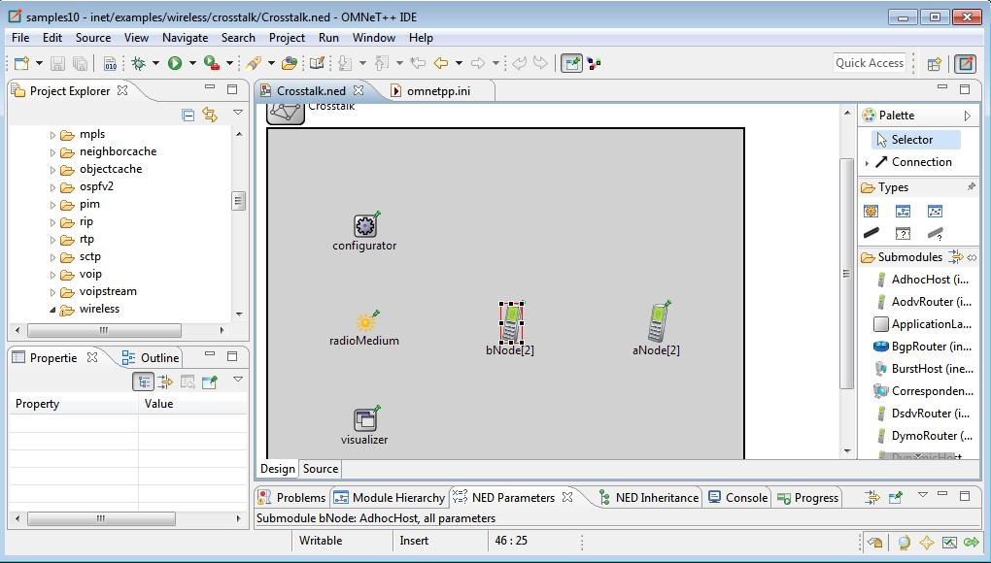**Crosstalk.ned:**

**Coding:**

**Crosstalk.ned:**

package inet.examples.wireless.crosstalk;

import inet.networklayer.configurator.ipv4.Ipv4NetworkConfigurator;

import inet.node.inet.AdhocHost;

import inet.physicallayer.ieee80211.packetlevel.Ieee80211DimensionalRadioMedium;

import inet.visualizer.contract.IIntegratedVisualizer; network Crosstalk

{

parameters:

submodules:

visualizer: <default("IntegratedCanvasVisualizer")> like IIntegratedVisualizer if hasVisualizer() {

parameters:

@display("p=100,300;is=s");

}

configurator: Ipv4NetworkConfigurator {

parameters:

@display("p=100,100;is=s");

}

radioMedium: Ieee80211DimensionalRadioMedium { parameters:

@display("p=100,200;is=s");

}

aNode[2]: AdhocHost {

parameters:

@display("r=,,#707070;p=400,200");

}

bNode[2]: AdhocHost {

parameters:

@display("r=,,#707070;p=250,200");

}

}

**Omnetpp.ini:**

[General]

network = Crosstalk

*#record-eventlog = true*

sim-time-limit = 0.1s

seed-set = 1

**.constraintAreaMinX = 0m

**.constraintAreaMinY = 0m

**.constraintAreaMinZ = 0m

**.constraintAreaMaxX = 100m

**.constraintAreaMaxY = 100m

**.constraintAreaMaxZ = 0m

*# mobility*

*.*Node[*].mobility.typename = "StationaryMobility"

*.*Node[*].mobility.initFromDisplayString = false

*# udp App*

*.*Node[*].numApps = 1

*.*Node[0].app[0].typename = "UdpSink"

*.*Node[*].app[0].typename = "UdpBasicApp"

*.*Node[*].app[0].localPort = 100

*.*Node[*].app[0].destPort = 100

*.*Node[*].app[0].messageLength = 1250B

*.*Node[*].app[0].startTime = exponential(100us)

*.*Node[*].app[0].sendInterval = exponential(100us)

*.aNode[*].app[0].destAddresses = "aNode[0]"

*.bNode[*].app[0].destAddresses = "bNode[0]"

# nic

*.*Node[*].wlan[*].radio.typename = "Ieee80211DimensionalRadio"

# medium

*.radioMedium.backgroundNoise.dimensions = "time frequency"

# radio

*.*Node[*].wlan[*].radio.transmitter.bandwidth = 20 MHz

*.*Node[*].wlan[*].radio.receiver.bandwidth = 20 MHz

*.*Node[*].wlan[*].radio.transmitter.dimensions = "time frequency"

*.aNode[*].wlan[*].radio.channelNumber = 1

*.bNode[*].wlan[*].radio.channelNumber = ${channelNumber=2..10}

**Step 4:** Click on Run button.

**Step 5:** After that following window will open.

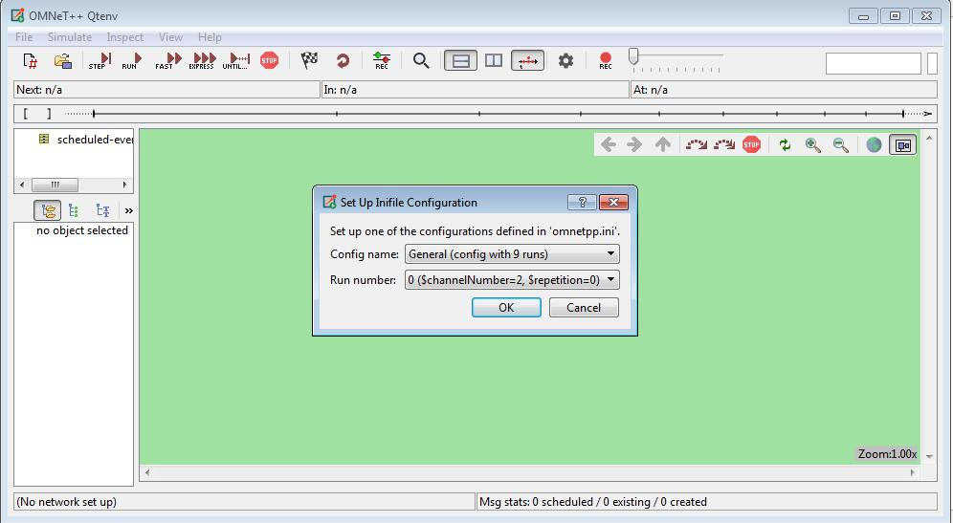

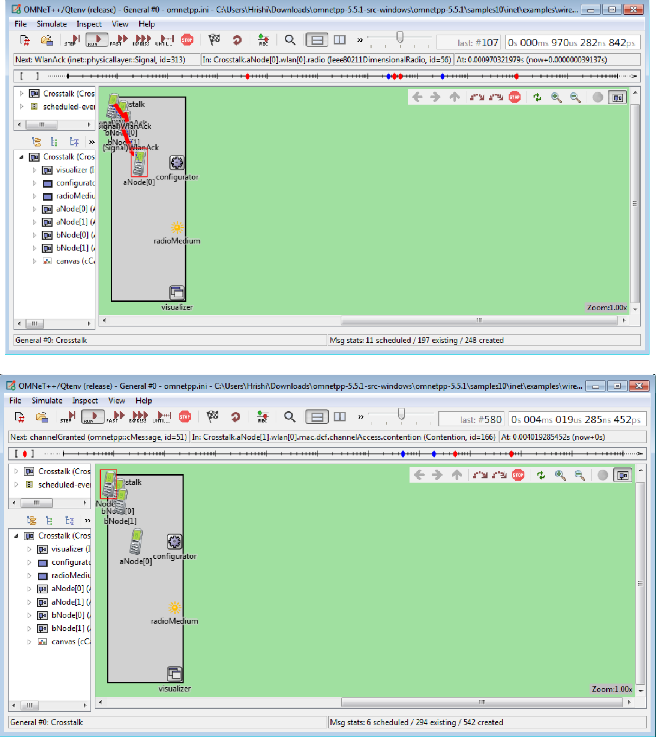**Step 6:** Click OK and then Click on RUN.

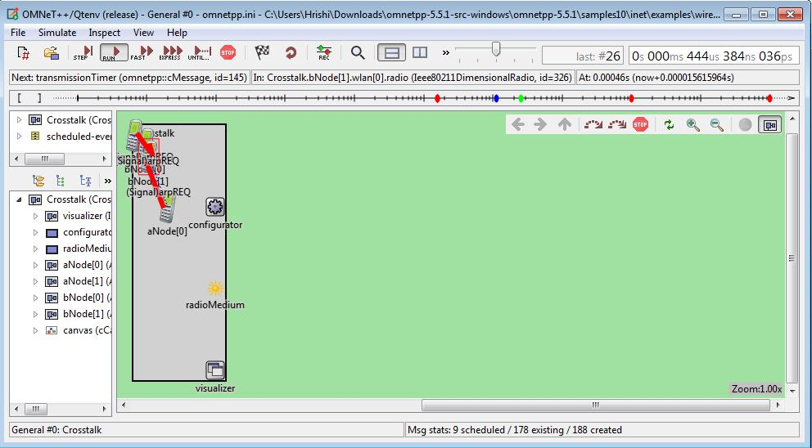**OUTPUT:**

**Conclusion:** We have learnt to wireless network in OMNET++.